Let’s take two goods,

Consumer good: Corn
Capital good: Robots

What is PPC?

- Is a graph that shows all the possibilities of two goods (which is capital and consumer) an economy can produce with the fixed amount of resource available.
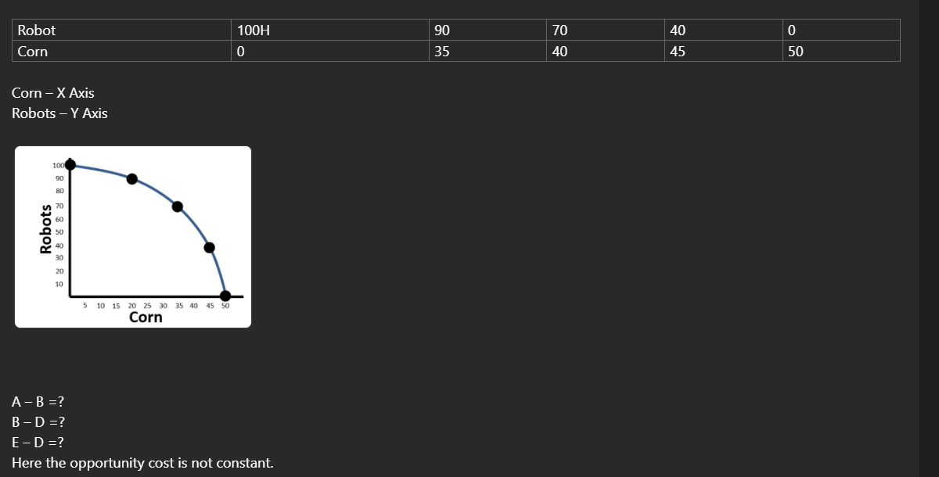
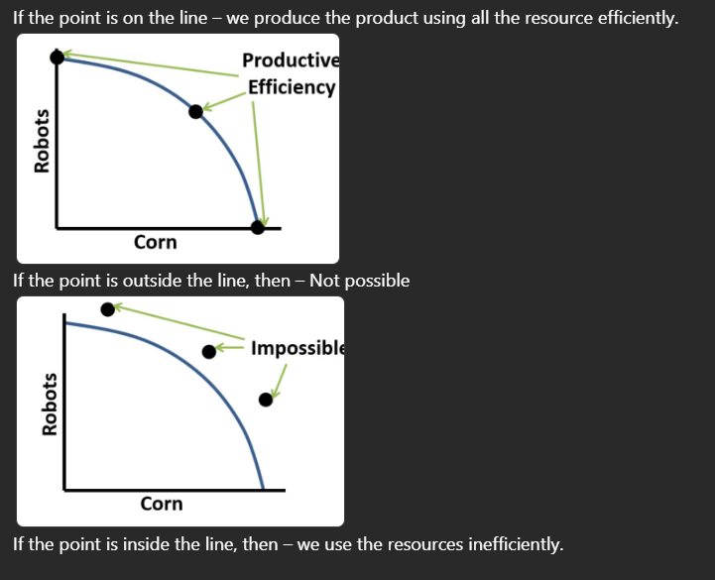
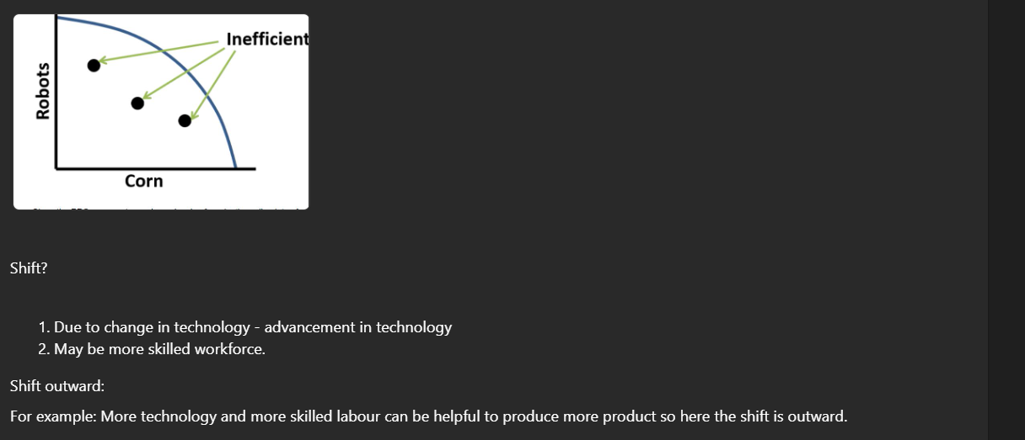
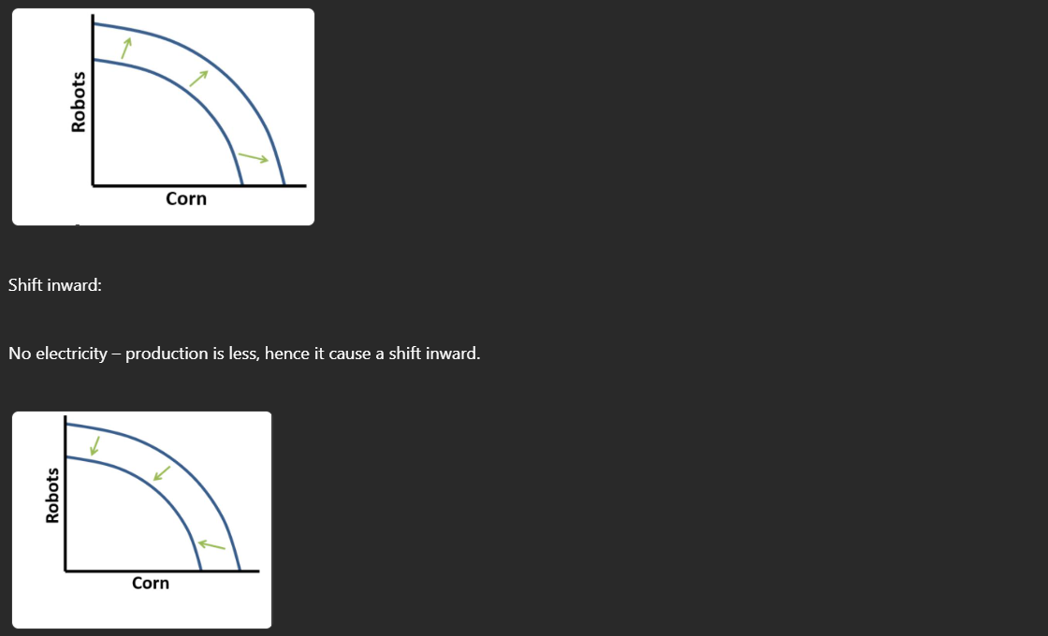
No Shift:
High unemployment: when the workers are alive and not utilized them properly can cause an inefficiency in resource utilization. This causes a shit inward.
How to find an opportunity cost on the PPC?
Opportunity cost is what you lose after making a choice. The PPC show opportunity cost related to different level of production. As the Economy below increase production of corn then it loses some number of robots and it goes on vice versa.
If the production possibility curve moves from point A to B, then production pf corn would increase from 20 to 35, but those extra 15 of corn are not free. This happens because the robots are reduced from 90 to 70. So here the opportunity cost of those extra 15 of corn is 20 robots (90-70). Similarly moving the production from B to A then it comes at a cost of 15 of corn.

